Report on

Predicting life Expectancy using Machine Learning
Organization-Smartinternz Internship

Report written by,

Punitha Challa

Project ID-SPS_PRO_215

B-TECH 3rd year CSE

TKR College Of Engineering and Technology

Table of Contents
1.INTRODUCTION
1.1 Overview
1.2 Purpose
2.LITERATURE SURVEY
2.1 Existing problem
2.2 Proposed solution
3.THEORITICAL ANALYSIS
3.1 Block diagram
3.2 Hardware / Software designing
4.EXPERIMENTAL INVESTIGATIONS
5.FLOWCHART
6.RESULT
7.ADVANTAGES & DISADVANTAGES
8.APPLICATIONS
9.CONCLUSION
10.FUTURE SCOPE
11.BIBILOGRAPHY
APPENDIX
A. Source code

Introduction
Prediction of individual life span based on characteristics evaluated at middle-age represents a challenging objective for aging research. In this study, we used machine learning algorithms to construct models that predict life span in a stock of genetically heterogeneous mice. Life-span prediction accuracy of 22 algorithms was evaluated using a cross-validation approach, in which models were trained and tested with distinct subsets of data. Using a combination of body weight and T-cell subset measures evaluated before 2 years of age, we show that the life-span quartile to which an individual mouse belongs can be predicted with an accuracy of 35.3% (±0.10%). This result provides a new benchmark for the development of life-span–predictive models, but improvement can be expected through identification of new predictor variables and development of computational approaches. Future work in this direction can provide tools for aging research and will shed light on associations between phenotypic traits and longevity.

Overview

Life expectancy is a statistical measure of the average time a human being is expected to live, Life expectancy depends on various factors: Regional variations, Economic Circumstances, Sex Differences, Mental Illnesses, Physical Illnesses, Education, Year of their birth and other demographic factors. This problem statement provides a way to predict average life expectancy of people living in a country when various factors such as year, GDP, education, alcohol intake of people in the country, expenditure on healthcare system and some specific disease related deaths that happened in the country are given.

Purpose
We aimed to develop a clinical decision support tool for clinicians counseling patients with localized prostate cancer. The tool would provide estimates of patient life expectancy based on the factors year,GDP,education,alcohol intake ,expenditure etc.

2.Literature Survey

2.1Existing Problem

Although there have been lot of studies undertaken in the past on factors affecting life expectancy considering demographic variables, income composition and mortality rates. It was found that effect of immunization and human development index was not taken into account in the past. Also, some of the past research was done considering multiple linear regression based on data set of one year for all the countries. Hence, this gives motivation to resolve both the factors stated previously by formulating a regression model based on mixed effects model and multiple linear regression while considering data from a period of 2000 to 2015 for all the countries. Important immunization like Hepatitis B, Polio and Diphtheria will also be considered.

2.2Proposed Solution
The data-set related to life expectancy, health factors for 193 countries has been collected from WHO data repository website and its corresponding economic data was collected from the United Nations website. Among all categories of health-related factors only those critical factors were chosen which are more representative. It has been observed that in the past 15 years, there has been a huge development in health sector resulting in improvement of human mortality rates especially in the developing nations in comparison to the past 30 years. Therefore, in this project we have considered data from year 2000-2015 for 193 countries for further analysis. The individual data files have been merged together into a single data-set.
The project uses immunization factors, mortality factors, economic factors, social factors and other health related factors to predict life expectancy of a country for a given year using a machine learning model.
Since the observations in this dataset are based on different countries, it will be easier for a country to determine the predicting factor which is contributing to lower value of life expectancy. This will help in suggesting a country, which area should be given importance in order to efficiently improve the life expectancy of its population.

Theoretical Analysis

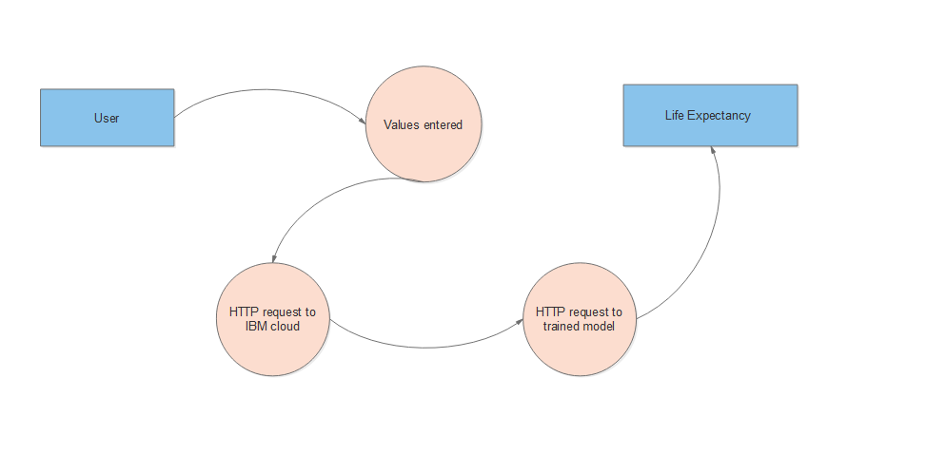

3.2 Hardware/Software Design

Hardware
- A laptop with 4 GB RAM
- A 2 GB CPU

Software
- IBM Cloud Account
- Jupyter Notebook
- Watson Studio Service
- Machine Learning Service
- Node Red Flow Application

3.Experimental Investigations
Increasing age is a risk factor for many diseases; therefore developing pharmacological interventions that slow down ageing and consequently postpone the onset of many age-related diseases is highly desirable. In this work we analyse data from the DrugAge database, which contains chemical compounds and their effect on the lifespan of model organisms. Predictive models were built using the machine learning method random forests to predict whether or not a chemical compound will increase Caenorhabditis elegans' lifespan, using as features Gene Ontology (GO) terms annotated for proteins targeted by the compounds and chemical descriptors calculated from each compound's chemical structure. The model with the best predictive accuracy used both biological and chemical features, achieving a prediction accuracy of 80%. The top 20 most important GO terms include those related to mitochondrial processes, to enzymatic and immunological processes, and terms related to metabolic and transport processes. We applied our best model to predict compounds which are more likely to increase C. elegans' lifespan in the DGIdb database, where the effect of the compounds on an organism's lifespan is unknown. The top hit compounds can be broadly divided into four groups: compounds affecting mitochondria, compounds for cancer treatment, anti-inflammatories, and compounds for gonadotropinreleasing hormone therapies.

FLOWCHART
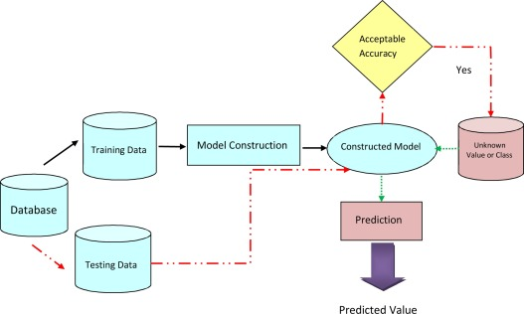

RESULT
The user should enter the credentials required for prediction.The average life expectancy prediction will be displayed on the screen.

Advantages and Disadvantages

Advantages
1.Identifies trends and patterns easily- Machine learning involves reviewing large volumes of data to discover specific trends and patterns that would most often not be apparent to humans. For example, machine learning will be useful for an e-commerce website like Amazon, to understand purchase histories and browsing behaviors of its users to cater to the right deals, products, and reminders that are relevant to them.
2.Automation- Machine learning does not require human intervention. It gives machines the ability to learn. It helps machines make predictions and improve the algorithms by themselves. Anti-virus software is a common example of this as they automatically filter new threats as & when they are recognized.
3.Continuous improvement- Machine learning algorithms improve in accuracy and efficiency as they gain experience. This helps them take better decisions.

Disadvantages
1.Time and resources- Machine learning requires massive resources to function. It may demand additional computing power. Machine learning requires enough time to let the algorithms learn & develop to fulfill their intended purpose with a considerable amount of accuracy and relevancy.
2.Interpretation of results- Accurately interpreting the results generated by the algorithms is a challenging task. One needs to exercise caution while choosing algorithms for their specific purpose.
3.Data acquisition- Machine learning needs massive datasets to train on. These must be unbiased/inclusive and of good quality. In certain situations, they may need to wait for new data to be generated.

Applications
- The project can be used as a basis to develop personalized health applications.
- As the model uses a wide range of features for prediction, it will be easier for a country to determine the predicting factor which is contributing to lower value of life expectancy. This will help in suggesting a country, which area should be given importance in order to efficiently improve the life expectancy of its population.
- The governments can plan and develop their health infrastructures by keeping the most correlated factors in mind.
- The project can help governments to keep track of their countries’ health status so they can plan for the future accordingly.

Conclusion
The project makes use of electronic medical records for predicting life expectancy. The potential use of project is not limited to health care in practice, but could also be useful in other clinical applications such as clinical trials. In clinical trials, outcomes often depend on prognostic factors. Automatic processing of medical records would enable quick and systematic stratification of patients based on their prognoses, which could be used to further reduce biases. The project makes a good use of machine learning in predicting life expectancy of a country that can help respective government in making policies that will serve for the benefit of the nation and entire humankind.

Future Works
Some future improvements can be made on current project. They are as follows:
- As more data comes, that can be fed to the model for more accurate predictions.
- Currently, the project is just a web application. It can be developed to support other platforms like Android, IOS and Windows Mobile.
- Other regression models can also be used for prediction and later the best among them should be chosen.
- User interface can be modified for various countries according to their regional languages.

Bibilography
[1] IBM Cloud setup [Online]. Available: https://www.ibm.com/cloud/get-started .
[2] IBM Developer, “Node-RED starter tutorial” [Online]. Available: https://developer.ibm.com/tutorials/how-to-create-a-node-red-starter-application/ .
[3] “Node-RED labs on the use of the Watson Developer Cloud services - watson-developer-cloud/node-red-labs.” [Online]. Available: https://github.com/watson-developer-cloud/node-red-labs .
[4] “Infuse AI into your applications with Watson AI to make more accurate predictions”. [Online]. Available: https://www.ibm.com/watson/products-services .
[5] IBM Watson, “Intro to IBM Watson”, 2018 [Online]. Available: https://www.youtube.com/watch?v=W3iPbFTAAds&feature=youtu.be .
[6] “Get an understanding of the principles of machine learning.” [Online]. Available: https://developer.ibm.com/technologies/machine-learning/series/learning-path-machine-learning-for-developers/ .
[7] IBM Developer, “IBM Watson Machine Learning: Get Started in IBM Cloud”, 2020 [Online]. Available: https://www.youtube.com/watch?v=NmdjtezQMSM .
[8] Watson Studio Workshop, “Chapter 4 Build and Deploy models in Jupyter Notebooks” [Online]. Available: https://bookdown.org/caoying4work/watsonstudio-workshop/jn.html .
[9] Kumar Rajarshi, “Life Expectancy (WHO) Statistical Analysis on factors influencing Life Expectancy”, 2018. [Online]. Available: https://www.kaggle.com/kumarajarshi/life-expectancy-who
[10] IBM Developer, “IBM Watson: Sign up for Watson Studio and Watson Knowledge Catalog”, 2019. [Online]. Available: https://www.youtube.com/watch?v=DBRGlAHdj48&list=PLzpeuWUENMK2PYtasCaKK4bZjaYzhW23L .
[11] IBM Developer, “IBM Watson Studio: Create a project”, 2019. [Online]. Available: https://www.youtube.com/watch?v=-CUi8GezG1I&list=PLzpeuWUENMK2PYtasCaKK4bZjaYzhW23L&index=2
[12] IBM Developer, “IBM Watson Studio: Jupyter notebook basics”, 2019 [Online]. Available: https://www.youtube.com/watch?v=Jtej3Y6uUng

APPENDIX

Source Code
The experiment is done under AutoAI. So the source code is present in the experiment itself.

Node Red Flow
